Sensitive detection of formaldehyde using an interband cascade laser near 3.6 μm

Wei Ren^{a,}*, Longqiang Luo^{b}, and Frank K. Tittel^{b}

ª Chinese University of Hong Kong, Department of Mechanical and Automation Engineering, New Territories, Hong Kong
^{b} Rice University, Department of Electrical & Computer Engineering, 6100 Main St., Houston, TX 77005, USA
* Corresponding author. Tel.: +852 3943 9486; fax: +852 2603 6002.
Email address: renwei@mae.cuhk.edu.hk (W. Ren), fkt@rice.edu (F. K. Tittel)

Abstract: We report the development of a formaldehyde (H₂CO) trace gas sensor using a continuous wave, thermoelectrically-cooled, low electrical-power-consumption, distributed-feedback interband cascade laser (ICL) at 3.6 µm. Wavelength modulation spectroscopy was used to detect the second harmonic spectra of a strong H₂CO absorption feature centered at 2778.5 cm⁻¹ in its v₁ fundamental vibrational band. A compact and novel multipass cell (7.6-cm physical length and 32-ml sampling volume) was implemented to achieve an effective optical path length of 3.7 m. A minimum detection limit of 6 parts per billion (ppb) at an optimum gas pressure of 200 torr was achieved with a 1-sec data acquisition time. An Allan-Werle deviation analysis was performed to investigate the long-term stability of the sensor system and a 1.5 ppb minimum detectable concentration could be achieved by averaging up to 140 sec. Absorption interference from atmospheric H₂O and CH₄ was also analyzed in this work and proved to be insignificant for the current sensor configuration.

Keywords: formaldehyde, absorption spectroscopy, interband cascade laser, trace gas detection

1. Introduction
Formaldehyde (H₂CO) is a colorless, pungent-smelling gas that plays an important role in tropospheric chemistry [1]. Primary H₂CO sources include vehicle exhaust and fugitive industrial emissions, while secondary H₂CO is produced mainly from the breakdown of primary volatile organic compounds (VOCs) via photochemical oxidation [2,3]. It is one of the most abundant gas-phase carbonyls in the atmosphere and can reach concentration levels in excess of 40 parts per billion (ppb) in polluted, urban environments [2,3]. The main loss processes include photolysis by ultraviolet (UV) radiation [4] and oxidation reaction with the OH radical to form HCO, H, and CO [1,5]. These radicals undergo further reactions to form HO₂, contributing to ozone (O₃) formation in the presence of NO_{x} (NO and NO₂) [3]. Precise measurements of H₂CO concentrations are critical to the complete understanding of HO_{x} (OH and HO₂) chemistry and O₃ formation.
In the manufacturing industry, H₂CO is frequently used as a substitute for adhesives such as urea-formaldehyde (UF) and phenol-formaldehyde (PF) resins to make resins. Those H₂CO regents are widely applied in fabricating furniture and decorating house. Hence, H₂CO is considered as one of the most serious indoor contamination present in new homes. H₂CO has been classified as carcinogenic to humans by the International Agency for Research on Cancer (IARC) since 2004. Numerous governmental agencies have also set reference values for the exposure to H₂CO, i.e., WHO reported that the concentration of H₂CO in residential indoor areas must not exceed 82 ppb for 30 min [6]. Accurate measurements and thus control of H₂CO concentration in indoor area are of great importance to reduce its effect on the human health. In addition, H₂CO has also been identified as a potential biomarker in breath analysis of humans. In exhaled breath from breast cancer patients, H₂CO concentration levels of ~1.2 ppm were observed compared to normal levels of tens of ppb [7]. A sensitive and reliable human breath H₂CO analyzer can provide a promising way for noninvasive, real-time, and point-of-care disease diagnostics and metabolic status monitoring.
Many methods have been explored to detect the H₂CO concentrations. Indoor H₂CO detection was investigated by analyzing samples using high-performance liquid chromatography (HPLC) [8] and gas chromatography (GC) [9]. HPLC can provide ppb to sub-ppb detection sensitivity, but is not suitable for field deployment due to its weight, bulk and long measurement time. Semiconductor gas sensors based on gas-sensitive films provide a good alternative in H₂CO monitoring due to their low cost and short response time [10–12]. However, the selectivity is a limitation of such sensors in addition to their relatively high detection limits (>300 ppb). Electrochemical H₂CO sensors have good sensitivity and selectivity, but are limited by their poor temporal stability (time response of hour) [13,14]. Hence, there exists a need for the development of highly sensitive, selective, fast and compact H₂CO analyzers.
Laser-based spectroscopic sensors can satisfy these requirements for accurate and sensitive trace gas measurements. Direct, in situ detection of atmospheric H₂CO via laser induced fluorescence (LIF) in a White-type multipass cell was reported with a minimum detection limit (MDL) of ∼0.051 ppb in a 1 sec sampling time [15]. In this sensor system, the laser pulse centered at 353.373 nm was generated by frequency-doubled Ti:Sapphire laser (3 kHz, 0.52 W), which was pumped by a Q-switched, doubled Nd:YAG laser (532 nm, 2.89 W). Davenport et al. [16] described a simple method for H₂CO detection using low resolution non-dispersive UV absorption spectroscopy. In this method, a 340-nm UV LED was collimated into a 195-mm gas cell to achieve a MDL of ~6.6 ppm with a response time of 20 sec. A cantilever enhanced photoacoustic spectrometer was developed to measure H₂CO from 1772 to 1777 cm⁻¹ using a mid-infrared quantum cascade laser (QCL) [17]. By detecting an absorption line at 1773.96 cm⁻¹, the MDL and the normalized noise equivalent absorption (NNEA) coefficient using wavelength modulation were 1.3 ppb and 6.04×10⁻¹⁰ W cm⁻¹ Hz^{-1/2}, respectively. Tunable diode laser absorption spectroscopy (TDLAS) based H₂CO sensor development and its application for atmospheric monitoring have been pioneered by Tittel et al. since 1997 using difference frequency generation (DFG) based laser sources [18–21]. Similar TDLAS systems using a multipass cell (~100-m path length) developed by Fried et al. [22] and Wert et al. [23] indicated H₂CO MDLs of 30 to 50 ppt for 1 min of averaging during airborne operation. Miller et al. [24] reported the integration of off-axis integrated cavity output spectroscopy (OA-ICOS) with an interband cascade laser (ICL) to achieve a MDL of 150 ppb H₂CO. The ICL housed in a liquid-nitrogen cryostat emitted powers of up to 12 mW and could be tuned from 2831.8 cm⁻¹ to 2833.7 cm⁻¹ by varying the laser injection current. Recently the application of optical feedback-cavity enhanced absorption spectroscopy for H₂CO trace gas analysis was reported by employing a QCL at 1769 cm⁻¹ to achieve a minimum detectable H₂CO mixing ratio of 60 ppt at 10 Hz [25]. The sensor response time of 3 sec was limited mainly by the sample exchange rate for a 20-sccm flow and 50-mBar sample pressure in a 20-cc sample volume.
We report here a novel H₂CO absorption sensor by taking advantages of two recent technological advances in continuous wave, thermoelectrically-cooled, low electrical-power-consumption, distributed feedback 3.6 μm ICLs, and a compact multipass gas cell. The 3.6 μm spectral region corresponds to the strongest H₂CO infrared bands of v₁ band centered at 2782.4575 cm⁻¹ (symmetric C-H stretch) and v₅ band centered at 2843.9685 cm⁻¹ (asymmetric C-H stretch), respectively [26]. The sensor provides a detection sensitivity of 6 ppb at 1-sec sampling time. The compact design and low power consumption make this sensor easy to deploy in stationary, mobile and airborne field applications.

2. Spectroscopic methodology and sensor configuration
2.1 Fundamentals of laser absorption spectroscopy
Laser-based absorption spectroscopy is a widely applied technique for many gas sensing measurements due to its fast time response and quantitative nature. In particular, wavelength modulation spectroscopy (WMS) which is an extension of direct absorption spectroscopy has been used extensively for sensitive gas detection. The fundamental theory of laser based absorption spectroscopy is well understood [27–31] and only described briefly to clarify the notation and units used in this paper. Continuous wave laser radiation with narrow spectral bandwidth is normally utilized for line-of-sight absorption measurements. When the laser radiation at a wavelength v passes through a uniform gas medium, the wavelength-dependent transmission τ_{v} is determined by Beer's law:
(1)
where I₀ and I_{t} are incident and transmitted radiation intensity, respectively; S(cm⁻²atm⁻¹) is the line-strength of the specific transition, P(atm) is the total gas pressure, x is the mole fraction of the absorbing species, φ_{v}(cm) is the line-shape function and L(cm) is the optical path length. The line-shape function φ_{v} is usually approximated using a Voigt profile characterized by the collision-broadened full-width at half maximum (FWHM) and Doppler FWHM.
In TDLAS measurements, the laser wavelength is normally scanned across the absorption features by applying a slow (Hz) sawtooth signal to the laser injection current. The WMS method applies an additional fast (kHz) sinusoid modulation (at frequency f) to the laser current. The modulated absorption signal detected using a photodiode is then processed through a lock-in amplifier to demodulate the signal at the fundamental modulation frequency (f) or its harmonics (2f, 3f, etc.). For one sawtooth period, the incident laser wavelength v(t) and intensity I₀(t) are modulated taking the following forms:
, | (2)
, | (3)
where (cm⁻¹) is the mean laser wavelength of the laser under modulation, a(cm⁻¹) the modulation depth, the average laser intensity, i_{m} the mth Fourier coefficient of the laser intensity, and φ_{m} the initial phase of the mth order intensity modulation. Previous experimental characterization of commercial diode lasers shows that the laser intensity modulation could be well described by a combination of the first two terms (m = 1, 2) [31]. Hence, the detector signal (D) which is a periodic function with period of 1/f can be expanded into Fourier series as:
, | (4)
where H_{k} is the kth order Fourier coefficient defined as discussed in references [30,31]. The harmonics of the detected laser intensity are extracted by lock-in amplifiers with a bandwidth determined by their low-pass filters. The case of k = 2 is generally of the highest interest in WMS, since the second harmonic signal (2f) is closely related to the absorption and background free. In this case, the lock-in amplifier functions by multiplying the detector signal with the reference sinusoid at 2f, and shifting the harmonic component to DC. A low-pass filter is then applied to isolate the DC value and eliminate all other components such as laser and electronic noises outside the filter bandwidth, making WMS particularly useful for probing pressure broadened and overlapping absorption features.

2.2 ICL characterization
H₂CO has its fundamental vibrational band with the C-H symmetric (v₁) stretching mode at 2782 cm⁻¹ [26,32]. Several laser-based H₂CO sensors [33–35] have already been reported by detecting this absorption band. Absorption spectra based on the HITRAN database [36] are computed for the standard air (1.86% H₂O, 327 ppm CO₂, 30 ppb O₃, 320 ppb N₂O, 150 ppb CO, 1.68 ppm CH₄, 20.7% O₂, and 77.4% N₂) mixed with 10 ppb H₂CO, to identify the optimal H₂CO transitions. Considering the possible absorption interference from ambient air (i.e., H₂O, CO₂, O₃, N₂O and CH₄) and the commercial availability of ICL sources in this wavelength range, two optimal diagnostic windows at ~2778 and ~2781 cm⁻¹ are identified in this work for H₂CO detection; see Fig. 1 for the spectral simulation.
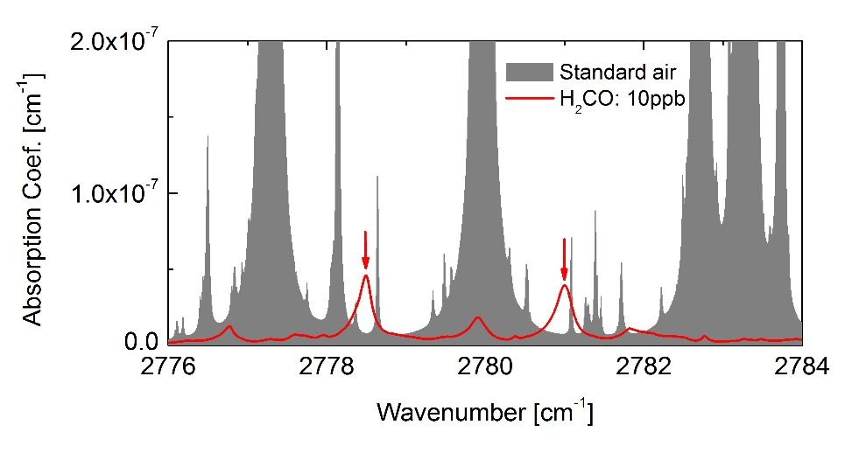
Fig. 1 Simulated absorption spectra of standard air (1.86% H₂O, 327 ppm CO₂, 30 ppb O₃, 320 ppb N₂O, 150 ppb CO, 1.68 ppm CH₄, 20.7% O₂, and 77.4% N₂) mixed with 10 ppb H₂CO at 296 K and 1 atm using the HITRAN database [36].
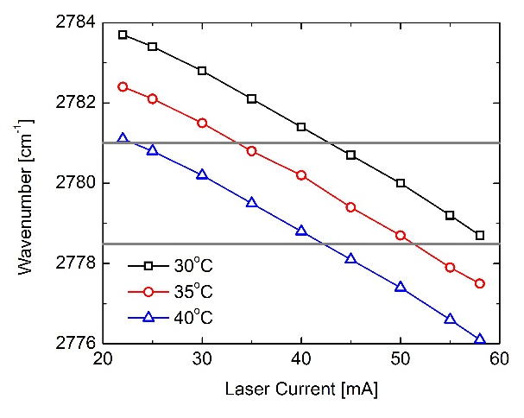  (a) | 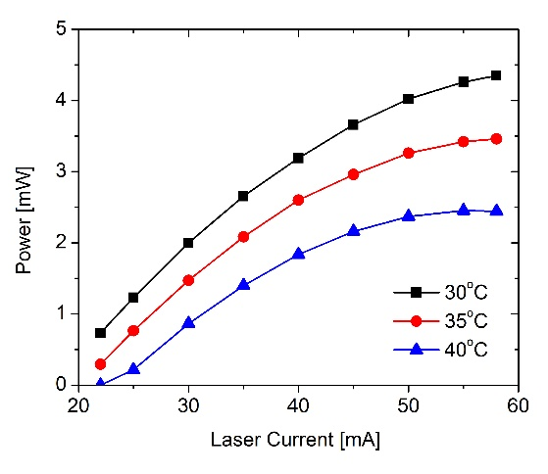  (b)
Fig. 2 Characterization of the ICL (a) wavenumber and (b) output power as a function of laser injection current.
The recent availability of ICLs with wavelengths between 3−4 µm enables the sensitive detection of trace gases such as formaldehyde (H₂CO) that possesses a strong absorption band in this particular wavelength spectral region [37]. A Nanoplus™ cw, TE-cooled ICL operating at the wavelength ~3.6 μm was selected as the laser source for H₂CO detection. The ICL performance of laser wavelength and power were first tested and characterized using a Thermo-Fissher™ Fourier transform infrared (FTIR) spectrometer with a resolution of 0.125 cm⁻¹ and an optical power meter (Ophir™), respectively. Figure 2(a) shows the wavelength tuning performance of the selected Nanoplus™ ICL. It covers a wavelength range of 2776 to 2784 cm⁻¹ by tuning the laser injection current between 22 and 58 mA and the laser temperature between 30 and 40 °C. The ICL’s output wavelength is nearly linearly proportional to the applied current at a fixed temperature, resulting in a current tuning coefficient of -0.139 cm⁻¹/mA. Similarly, the temperature tuning coefficient is determined to be -0.26 cm⁻¹/°C for the current and temperature operational range. Hence, the two H₂CO diagnostic features centered at 2778 cm⁻¹ and 2781 cm⁻¹ can be well covered by this ICL as indicated by the grey lines depicted in Fig. 2(a). Figure 2(b) presents the ICL output power in the current range from 22 to 58 mA at different temperatures. A maximum power of 4.3 mW can be achieved at an injection current of 58 mA and laser temperature of 30°C. It should be noted that at a current of ~50 mA, the ICL output power is 4 mW at 30°C, which is sufficient for most optical sensing applications.

2.3 Sensor configuration
In trace gas sensing, many sensing techniques such as multipass cell [38], cavity ring-down spectroscopy [39], and integrated cavity output spectroscopy [40] are utilized to achieve lowest detectable gas concentrations via increasing the effective optical path length. In this work, a novel multipass absorption cell combined with WMS detection strategy was utilized to enhance the H₂CO detection sensitivity.
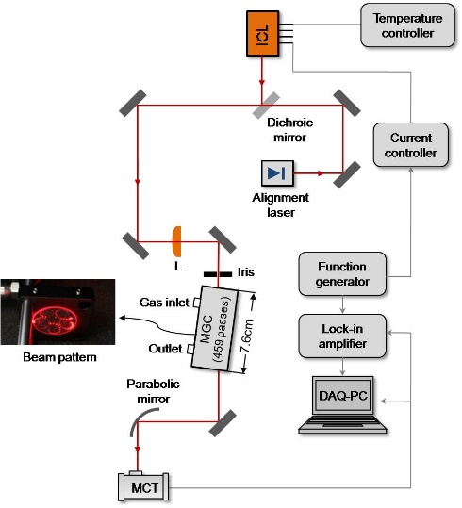
Fig. 3 Schematic of the H₂CO sensor design using a 3.6 μm ICL and a compact multipass absorption gas cell.
The experimental setup of this multipass cell based H₂CO sensor is schematically depicted in Fig. 3. The cw ICL housed in a TO66 mount was used as the monochromatic light source emitting at ~3.6 µm. The ICL current and temperature were controlled by a low noise current source (ILX Lightwave) and a precise temperature controller (Wavelength Electronics, MPT10000), respectively. A visible diode laser beam (λ = 630 nm) was aligned collinear with the mid-infrared beam by means of a dichroic mirror (ISP Optics™, model BSP-DI-25-3) to assist in the optical alignment of the sensor system. The ICL beam was coupled into a novel multipass absorption cell (Sentinel Photonics™, now Aeris Technologies™) using a ZnSb lens of 100-mm focus length. This dense patterned multipass cell consisted of two spherical mirrors separated by a distance of 7.6 cm, providing a sampling volume of 32 ml. By adjusting the distance and relative angle of the axis between two mirrors, dense spot patterns as shown in Fig. 3 can be achieved to provide an effective path length of 3.7 m. The spot pattern covers more of the mirror surface compared to a standard Herriott cell with a simple circle or elliptical pattern.
The laser beam exiting the compact multipass cell was focused via a parabolic mirror onto a thermoelectrically cooled mercury cadmium telluride (MCT, Vigo) detector, followed by wavelength modulation spectroscopy with second harmonic (WMS-2f) detection. In this work, a superposition of a 1 Hz voltage ramp and 5 kHz sinusoidal dither provided by a function generator (Tektronix AFG 3022B) was applied to the ICL current driver to scan and modulate the laser frequency across the H₂CO absorption features. The detector signal was processed by a lock-in amplifier (Signal Recovery 7265 DSP) to extract its 2f signal and subsequently collected by a NI DAQ card (NI-DAQ-AI-16XE-50, National Instrument).

3. Results and discussion
3.1 System optimization
The sensor response to the H₂CO absorption was characterized using a stable concentration of H₂CO in nitrogen mixture obtained from a permeation based gas generator (Kin-Tek Model 491M). In the Kin-Tek precision gas mixture generation system, the H₂CO liquid analyte is sealed inside a tube with a permeable membrane. A very small but stable flow (i.e., nanograms-per-minute) of H₂CO vapor was emitted through the tube wall at a constant temperature. The emission rate of the tube depends on the physical characteristics of its permeable membrane, as well as the permeability, temperature and partial pressure of the chemical analyte. With the emission rate characterized, immersing the permeation tube in a carefully controlled flow of dilution gas produces a precision trace gas mixture of the analyte. The mixture concentration could be varied by changing the flow rate of the dilution gas.
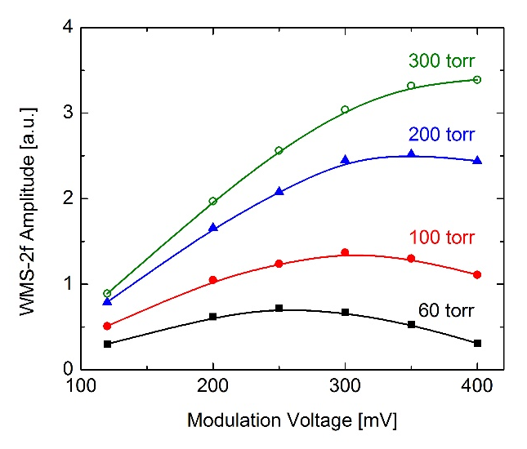
Fig. 4 Measured WMS-2f signal amplitude as a function of the laser modulation voltage at different pressures (60-300 torr).
The WMS-2f peak height is dependent on the line shape related to gas pressure and the laser wavelength modulation depth [29]. Hence, the test gas pressure and laser wavelength modulation depth need to be optimized to obtain the maximum WMS signal. The gas pressure inside the multipass cell is controlled by using a pressure controller (MKS, Model 649) and a diaphragm vacuum pump (KNF, type UN816.3 KTP). Figure 4 depicts the WMS-2f amplitudes of 750 ppb H₂CO measured at different pressures and modulation depths. The varied modulation depth was attained by adjusting the sinusoidal voltage applied to the laser current controller. In general, the WMS-2f amplitude increases with the higher gas pressure as shown in Fig. 4, but reaches a peak value at a specified modulation voltage if the gas pressure is fixed. The corresponding modulation voltage at the WMS-2f peak shifts to a larger value with increasing gas pressure. For example, the WMS-2f signal peaks at a modulation voltage of ~250 mV at a gas pressure of 60 torr, which is ~300 mV at 100 torr and ~350 mV at 200 torr, respectively. Despite the stronger WMS signal at higher pressures, the gas pressure inside the multipass cell was controlled below 200 torr in order to eliminate the possible cross-talk absorption interference between H₂CO and the neighboring H₂O and CH₄ absorption lines. Hence, the optimized gas pressure of 200 torr and a modulation voltage of 350 mV were selected in this study for the sensor development.
A typical WMS measurement of H₂CO absorption is illustrated in Fig. 5. The measurement shown in Fig. 5(a) covers the spectral range between 2778 and 2780.3 cm⁻¹ for 750 ppb H₂CO and 1% H₂O in air at room temperature (296 K) and 200 torr. Despite several H₂CO lines existing in this wavelength range, two strong H₂CO absorption features were observed at 2778.5 and 2779.9 cm⁻¹, respectively. The target H₂CO feature for sensor development was centered at 2778.5 cm⁻¹, compared to the other H₂CO feature at 2779.9 cm⁻¹ affected significantly by a neighboring H₂O transition (at 2779.96 cm⁻¹). The simulated absorption spectra using the HITRAN database at the same conditions are plotted in Fig. 5(b) for comparison. The simulation agrees well with the experimental results. It should be noted that there exists a water line centered at 2778.18 cm⁻¹ and a CH₄ line centered at 2778.64 cm⁻¹, which are close to the target H₂CO feature. The influence of the H₂O and CH₄ lines on the H₂CO detection sensitivity will be discussed later in this section.
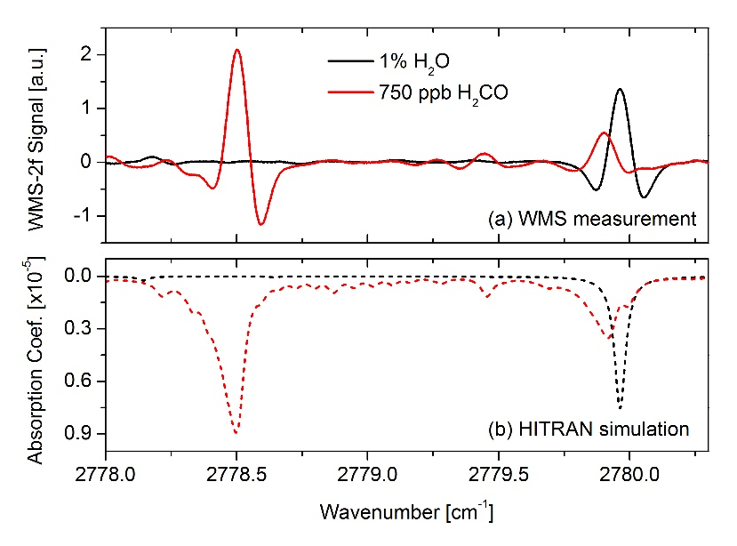
Fig. 5 Comparison of (a) the measured WMS-2f signal and (b) simulated absorption coefficient for 750 ppb and 1% H₂O at 200 torr. Simulation was performed using the HITRAN database [36].

3.2 Sensor calibration
The sensor calibration was performed using the same experimental setup depicted in Fig. 3 with precision H₂CO gas mixtures generated from the Kin-Tek permeation gas generator. Two typical WMS-2f profiles measured at the target wavelength of 2778.5 cm⁻¹ are plotted in Fig. 6, corresponding to calibrated H₂CO concentrations of 26.8 and 250 ppb, respectively. The relative difference of the detection SNR between these two measurements is clearly seen in Fig. 6. The WMS-2f signal was recorded and averaged for ~10 min for each calibrated concentration of the H₂CO mixture flowing through the multipass gas cell. The experimental results of measured WMS-2f signal at 2778.5 cm⁻¹ are plotted in Fig. 7 at different H₂CO concentrations. The H₂CO concentration covers a range from 26.8 ppb to 250 ppb to demonstrate the linear response of the sensor system. The coefficient of determination (R-squared value) for linear fitting is 0.997 and the relative difference between the calibrated and the measured H₂CO concentration based on the determined linear equation is within 8%.
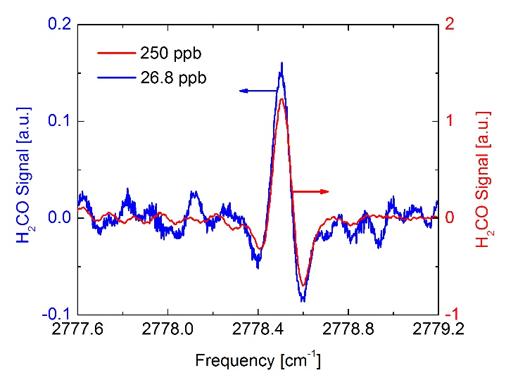
Fig. 6 Measured WMS-2f signal of the calibrated H₂CO mixtures (26.8 ppb and 250 ppb).
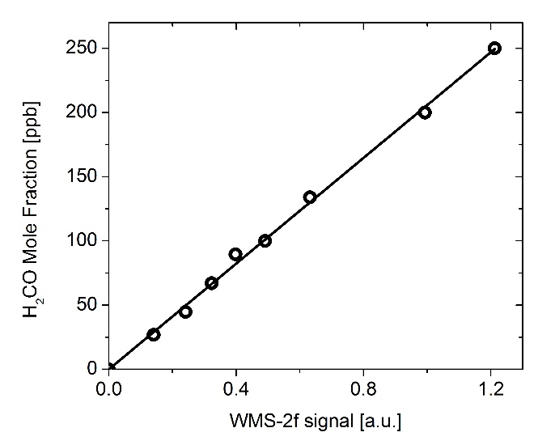
Fig. 7 WMS-2f amplitude measured at 2778.5 cm⁻¹ as a function of H₂CO concentration. Symbol, measurement; solid line, linear fit (linear fit equation: y = 0.03x+205.7).

3.3 Detection sensitivity analysis
The detection sensitivity of laser-absorption-based sensors is determined mainly by the overall absorbance, the spectral interference from other gas molecules, and the system noise. We discuss the detection sensitivity according to these three factors.
The spectral interference from neighboring molecular transitions caused by pressure broadening is the first important issue that affects the detection sensitivity in trace gas sensing. A brute force sensitivity simulation was performed using a numerical model to examine the interferences from those two absorption features of H₂O and CH₄. The numerical model was constructed based on the mathematical expressions of the WMS-2f technique as briefly discussed in Section 2.1; see also references [27–31] for further details. The spectroscopic parameters (i.e., line-position, line-strength, air-broadening coefficient) used in the simulation were from the HITRAN database [36]. A water absorption line centered at 2778.18 cm⁻¹ is relatively close to the targeted H₂CO feature at 2778.5 cm⁻¹ and its potential spectral interference was investigated. Figure 8(a) shows the WMS-2f spectral simulation of a 10-ppb H₂CO and a nearby H₂O absortion line with concentrations that varied between 0.1% and 2% at a total gas pressure of 200 torr. In the atmosphere or other gas sensing applications, the H₂O spans a much larger concentration range compared to H₂CO. Thus, the H₂CO concentration was changed by orders of magnitude in the simulation to demonstrate its influence on a H₂CO WMS-2f feature. The 2f peak-to-trough height of a 10-ppb H₂CO peak only decreases by 0.21% as the H₂O concentration increases from 0.1% to 2%. A similar evaluation was performed for the other interfering absorption of CH₄ centered at 2778.64 cm⁻¹ with concentration levels varied between 100 ppb and 5 ppm, as shown in Fig. 8(b). If the CH₄ present in the gas mixture has a concentration of 1 ppm and 5 ppm, the 2f peak-to-trough height of 10-ppb H₂CO peak decreases by 1.2% and 5%, respectively. Hence, the interference between these absorption features is insignificant for most atmospheric conditions if the total gas pressure is controlled to be <200 torr. The spectral cross-talk interference could be further reduced if a lower gas pressure was selected. In addition, the full spectral fitting method also helps to minimize the interference compared to the peak-to-trough signal amplitude adopted in the current study.
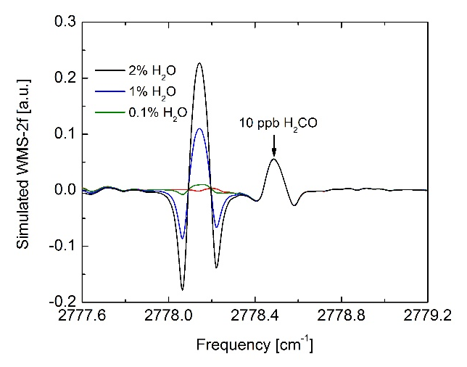  (a) | 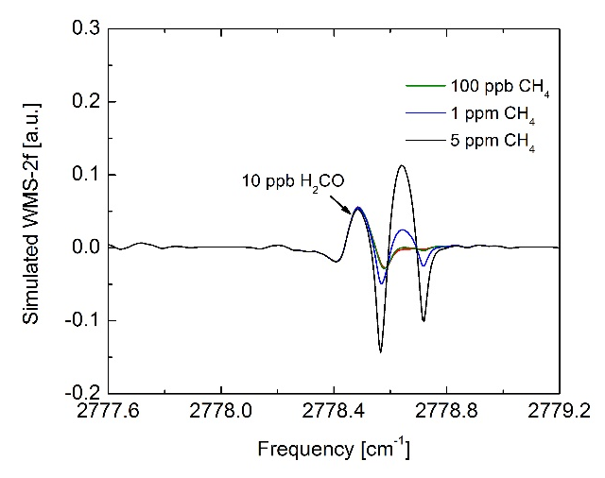  (b)
Fig. 8 Simulated WMS-2f spectral interferences between 10 ppb H₂CO and the nearby (a) H₂O with concentration varied between 0.1% and 2%, and (b) CH₄ with concentration varied between 100 ppb and 5 ppm, at a gas pressure of 200 torr.
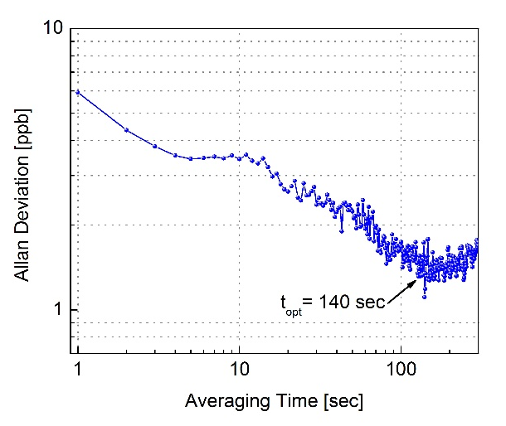
Fig. 9 Allan-Werle deviation in ppb of the WMS-2f signal as a function of the averaging time.
The long-term stability and precision of the H₂CO sensor were tested by monitoring a calibrated 100 ppb H₂CO mixture for 1 hour. Figure 9 shows an Allan-Werle deviation [41] plot for the 1-hour period sampling H₂CO mixture. The stability of the sensor system in a free running, non-wavelength locked mode allows averaging of up to 140 sec for the detection of H₂CO. At the sampling rate of 1 Hz, the MDL was measured to be 6 ppb. Considering the absorption line-strength of H₂CO at this wavelength, a gas pressure of 200 torr, and optical path length of 3.7 m, a minimum detection absorption coefficient of 6.5×10⁻⁸ cm⁻¹ was achieved using the current sensor configuration. Additionally, the Allan-Werle deviation shown in Fig. 9 reveals that the MDL can be improved to 1.5 ppb with an integration time of 140 sec.

4. Conclusion and future outlook
We have reported the development of a formaldehyde TDLAS sensor using an interband cascade laser at ~3.6 μm and a novel multipass absorption gas cell. The low power consumption of the ICL and the compact multipass cell of the sensor system allow its convenient field deployment. The absorption interference from neighboring H₂O and CH₄ lines was analyzed in this work and proved to be insignificant if low gas pressures (<200 torr) were used in the measurement. Wavelength modulation spectroscopy with second harmonic (WMS-2f) detection was conducted to achieve a 6-ppb MDL of H₂CO at 1 sec averaging time. The long-term stability and precision of this absorption sensor were examined and a 1.5-ppb minimum detectable concentration could be achieved by averaging up to 140 sec. Future work is planned to further improve the sensor detectivity to sub-ppb level by using a multipass cell with longer path length. The new sensor system will be installed in a mobile monitoring van for real time measurements of H₂CO emissions in the Greater Houston area.

Acknowledgements
We acknowledge the financial support from a National Science Foundation (NSF) ERC MIRTHE award, a NSF-ANR award for international collaboration in chemistry, “Next generation of Compact Infrared Laser based Sensor for Environmental monitoring (NexCILAS)”, and the Robert Welch Foundation grant C-0586. Ren acknowledges financial support the Direct Grant for Research (C001-4055041) from the Chinese University of Hong Kong.

References
[1] Y.G. Adewuyi, S.-Y. Cho, R.-P. Tsay, G.R. Carmichael, Importance of formaldehyde in cloud chemistry, Atmospheric Environ. 1967. 18 (1984) 2413–2420.
[2] L.G. Anderson, J.A. Lanning, R. Barrell, J. Miyagishima, R.H. Jones, P. Wolfe, Sources and sinks of formaldehyde and acetaldehyde: An analysis of Denver’s ambient concentration data, Atmos. Environ. 30 (1996) 2113–2123.
[3] C. Hak, I. Pundt, S. Trick, C. Kern, U. Platt, J. Dommen, et al., Intercomparison of four different in-situ techniques for ambient formaldehyde measurements in urban air, Atmos Chem Phys. 5 (2005) 2881–2900.
[4] R. Atkinson, Atmospheric chemistry of VOCs and NOx, Atmos. Environ. 34 (2000) 2063–2101.
[5] M. Lee, B.G. Heikes, D.W. O’Sullivan, Hydrogen peroxide and organic hydroperoxide in the troposphere: a review, Atmos. Environ. 34 (2000) 3475–3494.
[6] Committee on Sick House Syndrome: Indoor Air Pollution Progress Report. No. 4, Japan., (2002).
[7] S.E. Ebeler, A.J. Clifford, T. Shibamoto, Quantitative analysis by gas chromatography of volatile carbonyl compounds in expired air from mice and human, J. Chromatogr. B. Biomed. Sci. App. 702 (1997) 211–215.
[8] J.O. Levin, K. Andersson, R. Lindahl, C.A. Nilsson, Determination of sub-part-per-million levels of formaldehyde in air using active or passive sampling on 2,4-dinitrophenylhydrazine-coated glass fiber filters and high-performance liquid chromatography, Anal. Chem. 57 (1985) 1032–1035.
[9] J.R. Hopkins, T. Still, S. Al-Haider, I.R. Fisher, A.C. Lewis, P.W. Seakins, A simplified apparatus for ambient formaldehyde detection via GC-pHID, Atmos. Environ. 37 (2003) 2557–2565.
[10] C.-Y. Lee, C.-M. Chiang, Y.-H. Wang, R.-H. Ma, A self-heating gas sensor with integrated NiO thin-film for formaldehyde detection, Sens. Actuators B Chem. 122 (2007) 503–510.
[11] J. Wang, P. Zhang, J.-Q. Qi, P.-J. Yao, Silicon-based micro-gas sensors for detecting formaldehyde, Sens. Actuators B Chem. 136 (2009) 399–404.
[12] J. Wang, L. Liu, S.-Y. Cong, J.-Q. Qi, B.-K. Xu, An enrichment method to detect low concentration formaldehyde, Sens. Actuators B Chem. 134 (2008) 1010–1015.
[13] M. Hämmerle, E.A.H. Hall, N. Cade, D. Hodgins, Electrochemical enzyme sensor for formaldehyde operating in the gas phase, Biosens. Bioelectron. 11 (1996) 239–246.
[14] Q. Ma, H. Cui, X. Su, Highly sensitive gaseous formaldehyde sensor with CdTe quantum dots multilayer films, Biosens. Bioelectron. 25 (2009) 839–844.
[15] J.R. Hottle, A.J. Huisman, J.P. DiGangi, A. Kammrath, M.M. Galloway, K.L. Coens, et al., A Laser Induced Fluorescence-Based Instrument for In-Situ Measurements of Atmospheric Formaldehyde, Environ. Sci. Technol. 43 (2009) 790–795.
[16] J.J. Davenport, J. Hodgkinson, J.R. Saffell, R.P. Tatam, Formaldehyde sensor using non-dispersive UV spectroscopy at 340nm, Proceedings of SPIE (2014) 9141, 91410K–6.
[17] C.B. Hirschmann, J. Lehtinen, J. Uotila, S. Ojala, R.L. Keiski, Sub-ppb detection of formaldehyde with cantilever enhanced photoacoustic spectroscopy using quantum cascade laser source, Appl. Phys. B. 111 (2013) 603–610.
[18] Y. Mine, N. Melander, D. Richter, D.G. Lancaster, K.P. Petrov, R.F. Curl, et al., Detection of formaldehyde using mid-infrared difference-frequency generation, Appl. Phys. B. 65 (1997) 771–774.
[19] S. Friedfeld, M. Fraser, D. Lancaster, D. Leleux, D. Rehle, F. Tittel, Field intercomparison of a novel optical sensor for formaldehyde quantification, Geophys. Res. Lett. 27 (2000) 2093–2096.
[20] D.G. Lancaster, A. Fried, B. Wert, B. Henry, F.K. Tittel, Difference-frequency-based tunable absorption spectrometer for detection of atmospheric formaldehyde, Appl. Opt. 39 (2000) 4436–4443.
[21] D. Rehle, D. Leleux, M. Erdelyi, F. Tittel, M. Fraser, S. Friedfeld, Ambient formaldehyde detection with a laser spectrometer based on difference-frequency generation in PPLN, Appl. Phys. B Lasers Opt. 72 (2001) 947–952.
[22] A. Fried, Tunable diode laser measurements of formaldehyde during the TOPSE 2000 study: Distributions, trends, and model comparisons, J. Geophys. Res. 108 (2003).
[23] B.P. Wert, Signatures of terminal alkene oxidation in airborne formaldehyde measurements during TexAQS 2000, J. Geophys. Res. 108 (2003).
[24] J.H. Miller, Y.A. Bakhirkin, T. Ajtai, F.K. Tittel, C.J. Hill, R.Q. Yang, Detection of formaldehyde using off-axis integrated cavity output spectroscopy with an interband cascade laser, Appl. Phys. B. 85 (2006) 391–396.
[25] P. Gorrotxategi-Carbajo, E. Fasci, I. Ventrillard, M. Carras, G. Maisons, D. Romanini, Optical-feedback cavity-enhanced absorption spectroscopy with a quantum-cascade laser yields the lowest formaldehyde detection limit, Appl. Phys. B. 110 (2013) 309–314.
[26] A. Perrin, D. Jacquemart, F. Kwabia Tchana, N. Lacome, Absolute line intensities measurements and calculations for the 5.7 and 3.6 μm bands of formaldehyde, J. Quant. Spectrosc. Radiat. Transf. 110 (2009) 700–716.
[27] P. Kluczynski, Å.M. Lindberg, O. Axner, Background Signals in Wavelength-Modulation Spectrometry with Frequency-Doubled Diode-Laser Light. I. Theory, Appl. Opt. 40 (2001) 783–793.
[28] P. Kluczynski, Å.M. Lindberg, O. Axner, Background Signals in Wavelength-Modulation Spectrometry by use of Frequency-Doubled Diode-Laser Light. II. Experiment, Appl. Opt. 40 (2001) 794.
[29] P. Kluczynski, O. Axner, Theoretical Description Based on Fourier Analysis of Wavelength-Modulation Spectrometry in Terms of Analytical and Background Signals, Appl. Opt. 38 (1999) 5803–5815.
[30] G.B. Rieker, J.B. Jeffries, R.K. Hanson, Calibration-free wavelength-modulation spectroscopy for measurements of gas temperature and concentration in harsh environments, Appl. Opt. 48 (2009) 5546–5560.
[31] H. Li, G.B. Rieker, X. Liu, J.B. Jeffries, R.K. Hanson, Extension of wavelength-modulation spectroscopy to large modulation depth for diode laser absorption measurements in high-pressure gases, Appl. Opt. 45 (2006) 1052–1061.
[32] L.R. Brown, R.H. Hunt, A.S. Pine, Wavenumbers, line strengths, and assignments in the Doppler-limited spectrum of formaldehyde from 2700 to 3000 cm−1, J. Mol. Spectrosc. 75 (1979) 406–428.
[33] V. Catoire, F. Bernard, Y. Mébarki, A. Mellouki, G. Eyglunent, V. Daële, et al., A tunable diode laser absorption spectrometer for formaldehyde atmospheric measurements validated by simulation chamber instrumentation, J. Environ. Sci. 24 (2012) 22–33.
[34] J. Li, U. Parchatka, H. Fischer, Formaldehyde trace gas sensor based on a thermoelectrically cooled CW-DFB quantum cascade laser, Anal. Methods. (2014).
[35] G.W. Harris, G.I. Mackay, T. Iguchi, L.K. Mayne, H.I. Schiff, Measurements of formaldehyde in the troposphere by tunable diode laser absorption spectroscopy, J. Atmospheric Chem. 8 (1989) 119–137.
[36] L.S. Rothmana, I.E. Gordon, A. Barbe, D.Chris Benner, P.F. Bernath, M. Birk, V. Boudon, L.R. Brown, A. Campargue, J.-P. Champion, K. Chance, L.H. Coudert, V. Dana, V.M. Devi, S. Fally, J.-M. Flaud, R.R. Gamache, A. Goldman, D. Jacquemart, I. Kleiner, N. Lacome, W.J. Lafferty, J.-Y. Mandin, S.T. Massie, S.N. Mikhailenko, C.E. Miller, N. Moazzen-Ahmadi, O.V. Naumenko, A.V. Nikitin, J. Orphal, V.I. Perevalov, A. Perrin, A. Predoi-Cross, C.P. Rinsland, M. Rotger, M. Šimečková, M.A.H. Smith, K. Sung, S.A. Tashkun, The HITRAN 2008 molecular spectroscopic database, J. Quant. Spectrosc. Radiat. Transf. 110 (2009) 533–572.
[37] S. Lundqvist, P. Kluczynski, R. Weih, M. von Edlinger, L. Nähle, M. Fischer, A. Bauer, S. Hofling, J. Koeth, Sensing of formaldehyde using a distributed feedback interband cascade laser emitting around 3493 nm, Appl. Opt. 51 (2012) 6009–6013.
[38] D. Herriott, H. Kogelnik, R. Kompfner, Off-Axis Paths in Spherical Mirror Interferometers, Appl. Opt. 3 (1964) 523–526.
[39] A. O’Keefe, D.A.G. Deacon, Cavity ring‐down optical spectrometer for absorption measurements using pulsed laser sources, Rev. Sci. Instrum. 59 (1988) 2544–2551.
[40] A. O’Keefe, Integrated cavity output analysis of ultra-weak absorption, Chem. Phys. Lett. 293 (1998) 331–336.
[41] P. Werle, R. Mücke, F. Slemr, The limits of signal averaging in atmospheric trace-gas monitoring by tunable diode-laser absorption spectroscopy (TDLAS), Appl. Phys. B. 57 (1993) 131–139.

