Quartz enhanced photoacoustic H₂S gas sensor based on a fiber-amplifier source and a custom tuning fork with large prong spacing

Hongpeng Wu¹, Angelo Sampaolo^{2,3}, Lei Dong^{,3,a)}, Pietro Patimisco², Xiaoli Liu¹, Huadan Zheng¹, Xukun Yin¹, Weiguang Ma¹, Lei Zhang¹, Wangbao Yin¹, Vincenzo Spagnolo², Suotang Jia¹ and Frank K. Tittel³

¹ State Key Laboratory of Quantum Optics and Quantum Optics Devices, Institute of Laser Spectroscopy, Shanxi University, Taiyuan 030006, China
²Dipartimento Interateneo di Fisica, Università degli Studi di Bari and Politecnico di Bari, CNR-IFN UOS BARI, Via Amendola 173, Bari, Italy
³ Department of Electrical and Computer Engineering, Rice University, Houston, TX 77004, USA

A quartz enhanced photoacoustic spectroscopy (QEPAS) sensor, employing an erbium-doped fiber amplified laser source and a custom quartz tuning fork (QTF) with its two prongs spaced ~800 μm, is reported. The sensor employs an acoustic micro-resonator (AmR) and on-beam QEPAS configuration. Both length and vertical position of the AmR are optimized in terms of signal-to-noise ratio, significantly improving the QEPAS detection sensitivity by a factor of ~40, compared to the case of a sensor using a bare custom QTF. We employed the fiber-amplifier-enhanced QEPAS sensor for H₂S trace gas detection, reaching a sensitivity of ~890 ppb at 1s integration time, similar to those obtained with a power-enhanced QEPAS sensor equipped with a standard QTF, but with the advantages of easy optical alignment, simple installation and longer-term stability.

Laser based trace gas detection is widely used in applications, such as environmental monitoring, industrial process control and medical diagnostics.¹⁻⁴ Quartz enhanced photoacoustic (QEPAS) is a well-established sensor technique for detecting and quantifying trace gas species, in which a quartz tuning fork (QTF) is employed to detect acoustic oscillations induced in an absorbing gas by modulated optical radiation.^{5,6} In a conventional QEPAS setup, an acoustic micro-resonator (AmR), formed by one or two metallic thin tubes, is usually used in an “off beam” or “on beam” configuration to obtain a higher detection sensitivity.⁶⁻⁹ Typically the “on beam” configuration provides the best QEPAS signal-to-noise ratio.⁶ The combination of a QTF and an AmR is usually referred to as a spectrophone. It is critical to avoid laser beam illumination of the spectrophone for both configurations, since the radiation blocked by them results in an undesirable nonzero background and hence strongly limiting the sensor detection sensitivity.¹⁰⁻¹²
One of the fundamental features of the QEPAS technique is that the detection sensitivity of QEPAS based sensors is proportional to excitation laser power.¹³⁻¹⁵ This makes QEPAS based sensor performance benefit from the development of the high-power semiconductor lasers or from the enhanced excitation laser power.¹⁶ An optical fiber amplifier is an excellent choice for boosting laser power.^{17,18} Its basic operating principle requires a short length optical fiber doped with a small amount of rare-earth ion, such as erbium, and a semiconductor diode as input laser source. In principle, an optical fiber amplifier can achieve amplification factors of up to 3 orders of magnitude for input signals that occur within the gain bandwidth of the dopant, in a wide range of wavelengths (0.65-2 μm).¹⁴ Benefitting from the development of the telecommunication industry, in which the laser power is boosted for delivering optical signals over long distances, robust optical fiber amplifiers operating in three telecommunication bands (1450–1550 nm,1520–1570 nm, and 1565–1610 nm) are commercially readily available at low cost. Recently, a first demonstration of a QEPAS sensor employing a standard QTF and a fiber amplifier for sub-ppm H₂S detection was reported.¹² As the gap size of standard QTF prongs is only ~0.3 mm, an AmR in a “off beam” configuration was employed to reduce the noise induced by stray light hitting the spectrophone.⁸ Even so, the offset of the sensor background noise was ~17 times higher than the theoretical thermal noise value. In addition, an electrical modulation cancellation method (E-MOCAM) was employed to remove this nonzero background, which, however, resulted in a complex sensor system with a poor long-term stability.
In this letter, we report the development of a fiber-amplifier-enhanced QEPAS sensor for H₂S detection employing an erbium-doped fiber amplified 1582 nm distributed feedback (DFB) laser and a custom QTF having a spacing of ~800 μm between the QTF prongs. This approach combines the main benefits of conventional QEPAS technique, with the merit of using a watt-level excitation laser source, provided by a commercially available erbium-doped fiber amplifier (EDFA). In addition, the employment of a custom QTF with large prong spacing allows the use of AmR in “on-beam” configuration. As a result, the fiber-amplifier-enhanced QEPAS sensor is characterized by easy optical alignment, simple installation and long-term stability.
The custom QTF and standard QTF are schematically shown in Fig. 1. Their main geometrical parameters and electrical parameters¹⁹ at room temperature (T=297.2 K) and atmospheric pressure (P₀= 760 Torr) are reported in Table. І.
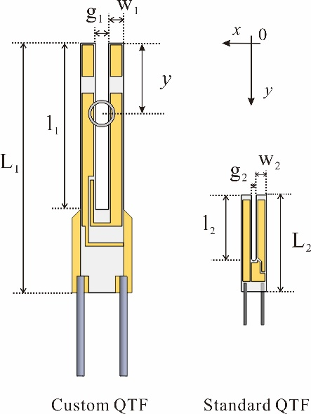
FIG. 1 Custom QTF on an on-beam configuration and standard QTF configuration with respective notation of their dimensions. The tubes were centered between the tines. y is the distance from the QTF opening to the center of the tubes. The proportion of their dimensions represents the actual size. Chromium/gold layers are deposited on both sides of the custom QTF providing electrical contacts similar to a standard QTF.

TABLE. І Dimensions and electrical parameters of a custom QTF and a standard QTF. The electrical parameters of custom QTF were measured in pure N₂ at atmospheric pressure (P₀= 760 Torr) and room temperature (T = 297.2 K), while the electrical parameters of standard QTF were typical values in these conditions.
 | geometrical parameters |  |  |  | electrical parameters
 | g (μm) | l (mm) | w (mm) | L (mm) | f₀ (Hz) | Q-factor | R(kΩ)
custom QTF | 800 | 10 | 0.9 | 15 | 7205 | 8536 | 286
standard QTF | 300 | 3.8 | 0.6 | 6 | 32768 | 12000 | 120

Standard photolithographic techniques are used to etch the custom QTF, starting from a z-cut quartz wafer. Chromium/gold contacts are deposited on both sides of the QTF.²⁰ The custom QTF has a similar geometry as the standard QTF, but is ~4.6 times larger in size. Spagnolo et al. have demonstrated theoretically²¹ and experimentally^{19, 20} that the custom QTF behaves like a standard QTF transducer in terms of Q-factor and resonance frequency. Hence, the standard QTF can be replaced with a custom QTF in QEPAS sensing system.
A schematic of the experimental setup used to demonstrate the performance of the fiber-amplifier-enhanced QEPAS sensor with a custom tuning fork is shown in Fig. 2. Mostly thanks to the large prongs spacing, we were able to employ a “on beam” QEPAS configuration to further improve the sensor detection sensitivity. A distributed feedback (DFB) laser (FITEL Inc. Model FRL15DCWD-A82) with a wavelength of 1582.1 nm was used as the excitation source. The near-infrared DFB laser was mounted onto a driver board which was used to control the laser temperature and current by means of a computer. A ramp signal generated from a computer scans the laser wavelength across the absorption line. In addition, a sine wave signal modulates the laser wavelength at a frequency f=f₀/2. The DFB laser beam was directed to the EDFA (Connect Laser Technology Ltd. Model MFAS-L-EY-B-MP) by means of an optical fiber. An opto-isolator (Connect Laser Technology Ltd. Model A12104132) was utilized to protect the DFB laser against back reflections. The output laser beam from the opto-isolator was directed to a 0.22 mm-diameter light spot by a fiber collimator (OZ optics Ltd. Model LPC-01), and then passed through the AmR and between the QTF prongs without touching any surfaces. The output from the QTF is connected to a low noise transimpedance amplifier with a feedback resistor of 10 MΩ and directed to a lock-in amplifier (Stanford Research Systems, Model SR830) for 2f detection.²² The lock-in amplifier was set to a 12 dB/oct filter slope and a time constant τ= 300 ms corresponding to a detection bandwidth of △f = 0.833 Hz.

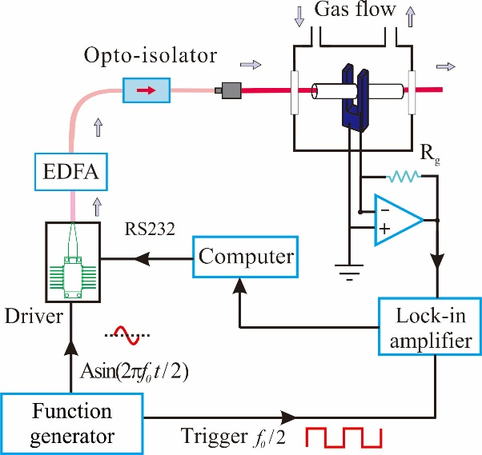

FIG. 2 Schematic of fiber-amplifier-enhanced QEPAS sensor using a custom tuning fork and an erbium-doped fiber amplifier.

Performances of this sensor spectrophone were optimized by selecting CO₂ as target gas in a certified gas mixture of 5% CO₂ in N₂ at atmospheric pressure and room temperature. The selected CO₂ target line is located at 6325.1374 cm⁻¹ with a line intensity of 1.155×10⁻²³ cm·mol⁻¹.²³ The output power of the EDFA was ~1,500 mW. The optimum AmR vertical position was identified by using a pair of tubes whose inner diameter (r) and length (l) were 1.3 mm and 12 mm, respectively. The gaps between the QTF and the tubes were 30 μm. The highest signal amplitude was achieved when the distance y between the tube center and top surface of the QTF tines is ~1.2 mm, as shown in Fig. 3a.
Since variations in l as small as 0.2 mm have a significant impact on the spectrophone properties, six AmRs with different l were tested for further improving the detection sensitivity.⁷ D.V. Serebryakov et al. confirmed that the optimum length of the tube is between λ_{s}/4 and λ_{s}/2, where λ_{s} is the sound wavelength (λ_{s}~47 mm for f₀~7205 Hz).²⁴ The length of the AmRs were in the range of 0 mm (bare QTF) to λ_{s}/2~23 mm. The second-harmonic QEPAS signals from the sensor with six different AmRs were detected, as shown in Fig. 3. This studies revealed that the optimized length of the tube (r=1.3 mm) for a custom QTF was l=23 mm (~λ_{s}/2), and that the use of an optimized AmR can improve the signal-to-noise ratio (SNR) by a factor of up to ~40, compared to the case of a bare custom QTF. Longer tubes have not been tested due to high difficulty in alignment of the laser beam through longer AmR tubes and its focalization between the QTF prongs without hitting both them.
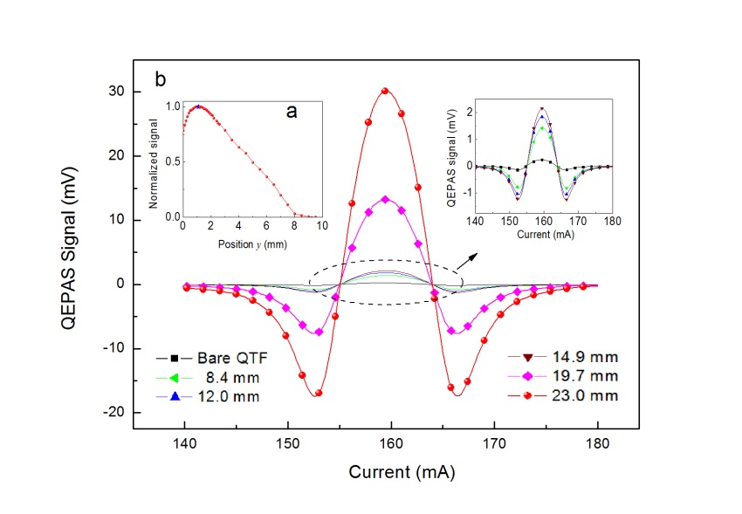
FIG. 3 (a) The normalized signal amplitude as a function of the AmR (r=1.3 mm, l=12 mm) vertical axial position between the tube center and top surface of the custom QTF tines. (b) Second-harmonic QEPAS signal for the sensor with five different AmRs. The signal of the fiber-amplifier-enhanced QEPAS sensor with a bare custom QTF was also shown. All spectra were acquired at atmospheric pressure (P₀= 760 Torr) and room temperature (T= 297.2 K).

The background noise, Q-factor and SNR as a function of l is plotted in Fig. 4. The Q-factor gradually decreases with l. This implies that the acoustic coupling between the QTF and AmR is more efficient for longer tube length and the high-Q QTF transfer energy occurs primarily via coupling to the low-Q AmR oscillator.^{25,26} Therefore, the SNR increases with l to its maximum value of l=23 mm. The observed gradual rising of the background noise is due to the increasing difficulty in aligning the high power laser beam passing through the AmR and the QTF without optical contact.
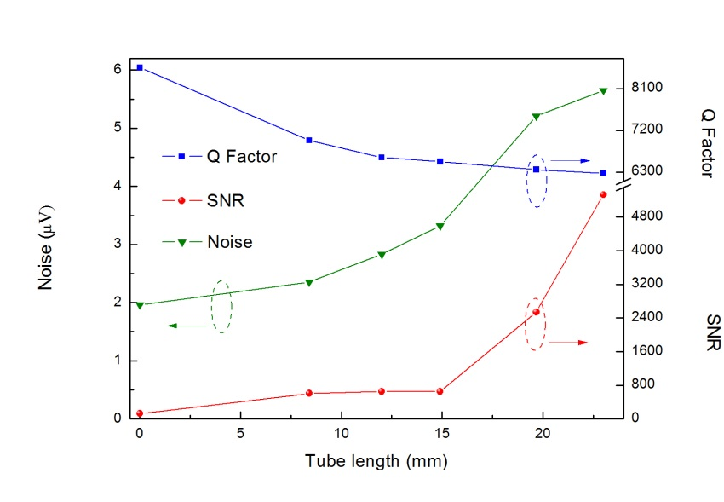
FIG. 4 Q-factor (blue square symbols), SNR (red dot symbols) and background noise (green triangle symbols) of the fiber amplified enhanced QEPAS sensor as a function of AmR tube length.

As second step, the detection sensitivity of an optimized fiber-amplifier-enhanced sensor for H₂S detection was investigated. A H₂S absorption line at 6320.6 cm⁻¹ with a line intensity of 1.1×10⁻²² cm·mol⁻¹ was selected as the target line.²³ The 2f signal measured for a certified 50 ppm H₂S:N₂ mixture with a current modulation depth of 18 mA at atmospheric pressure and room temperature is shown in Fig. 5. The selected target line merges with weaker sidebands located at 6320.5 cm⁻¹ and 6320.9 cm⁻¹, thus resulting in slight asymmetry of the 2f QEPAS signal. A 1 σ minimum detectable concentration limit of 890 ppb was obtained for a 1 s data acquisition time and 1,520 mW laser power, which is similar to that obtained by a fiber-amplifier-enhanced QEPAS sensor with a standard QTF (730 ppb),¹² but with a significantly simpler sensor configuration. The corresponding normalized noise equivalent absorption (NNEA) coefficient for H₂S is 1.29 × 10⁻⁸ W·cm⁻¹/√Hz.
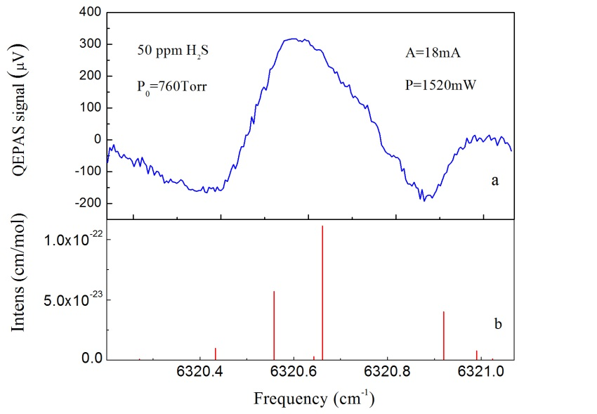
FIG. 5 (a) Spectral scan of 50 ppm H₂S in N₂ at atmospheric pressure and room temperature, acquired with a modulation depth of 18 mA and 1s integration time. (b) Line strengths of the main H₂S transitions, as reported in the HITRAN database, ²² falling in the spectral range corresponding to the frequency span of Fig. 5(a).

In order to evaluate the long-term stability of the fiber-amplifier-enhanced QEPAS sensor, we performed an Allan–Werle deviation analysis, ²⁷ measuring and averaging the QEPAS signal at zero H₂S concentration (pure N₂), as shown in Fig. 6. The Allan–Werle deviation for all time sequences closely follows a 1/√t dependence over the entire duration of the measurement series, which indicates that white noise of the QTF remains the dominant noise source and the sensor allows data averaging without base line or sensitivity drift on a more than 1,000 second time scale.
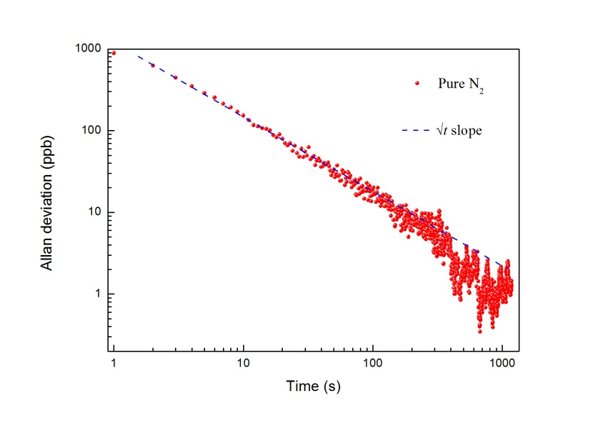
FIG. 6 Allan–Werle deviation as a function of the data averaging period. Solid circles trace: laser frequency was locked to a H₂S absorption line at 6320.6 cm⁻¹, the data acquisition time was 1 s. Dashed line represents 1/√t slope.

In conclusion, a fiber-amplifier-enhanced QEPAS sensor with a custom QTF was developed for H₂S detection. The larger spatial separation between the QTF prongs allows the QEPAS based sensors benefit from the power boosted by an EDFA, while preventing the prongs and AmR to be illuminated by stray light, thus facilitating the assembly of the spectrophone and improving the long-term stability of the sensor. Our results show that the detection sensitivity of the sensor was improved by a factor of ~40 times, when implementing and optimizing an “on beam” AmR configuration. Further improvement of the detection sensitivity can be expected by operating at low gas pressure and by further optimizing the AmR geometrical parameters, such as inner and outer tube diameters and QTF-tube spacing.

Acknowledgments
Lei Dong acknowledges support by National Natural Science Foundation of China (Grant #s. 61275213, 61108030), the Shanxi Natural Science Foundation (2013021004-1), and the Shanxi Scholarship Council of China (2013-011, 2013-01). Frank Tittel acknowledges support by the National Science Foundation (NSF) ERC MIRTHE award and the Robert Welch Foundation (Grant C-0586). The authors from Dipartimento Interateneo di Fisica di Bari acknowledge financial support from two Italian research projects: PON02 00675 and PON02 00576.

References
¹Y. Ma, X. Yu, G. Yu, X. Li, J. Zhang, D. Chen, R. Sun, and F. K. Tittel, Appl. Phys. Lett. 107, 091114 (2014).
²N. Petra, J. Zweck, A. A. Kosterev, S. E. Minkoff, and D. Thomazy, Appl. Phys. B 94, 673 (2009).
³Y. Cao, W. Jin, L. Ho, and Z. Liu, Opt. Lett. 37, 214 (2012).
⁴L. Dong, J. Wright, B. Peters, B. A. Ferguson, F. K. Tittel, and S. McWhorter, Appl. Phys. B 107,459 (2012).
⁵A. A. Kosterev, Y. A. Bakhirkin, R. F. Curl, and F. K. Tittel, Opt. Lett. 27, 1902 (2002).
⁶P. Patimisco, G. Scamarcio, F. K. Tittel, and V. Spagnolo, Sensors 14, 6165 (2014)
⁷L. Dong, A. A. Kosterev, D. Thomazy, and F. K. Tittel, Appl. Phys. B 100, 627 (2010).
⁸K. Liu, X. Guo, H. Yi, W. Chen, W. Zhang, and X. Gao, Opt. Lett. 34, 1594 (2009).
⁹H. Yi, K. Liu, W. Chen, T. Tan, L. Wang, and X. Gao, Opt. Lett. 36, 481 (2011).
¹⁰V. Spagnolo, A. A. Kosterev, L. Dong, R. Lewicki, and F. K. Tittel, Appl. Phys. B 100, 125 (2010).
¹¹L. Dong, V. Spagnolo, R. Lewicki, and F. K. Tittel, Opt. Express 19, 24037 (2011).
¹²H. Wu, L. Dong, H. Zheng, X. Liu, X. Ying, W. Ma, L. Zhang, W. Yin, S. Jia, and F. K. Tittel, Sens. Actuators B: Chem. 221, 666 (2015).
¹³S. Borri, P. Patimisco, I. Galli, D. Mazzotti, G. Giusfredi, N. Akikusa, M. Yamanishi, G. Scamarcio, P. D. Natale, and V. Spagnolo, Appl. Phys. Lett. 104, 91114 (2014).
¹⁴M. E. Webber, M. Pushkarsky, and C. K. N. Patel, Appl. Opt. 42, 2119 (2003).
¹⁵Y. Cao, W. Jin, L. Ho, and Z. Liu, Opt. Lett. 37, 214 (2012).
¹⁶L. Dong, H. Wu, H. Zheng, Y. Liu, X. Liu, W. Jiang, L. Zhang, W. Ma, W. Ren, W. Yin, S. Jia, and F. K. Tittel, Opt. Lett. 39, 2479 (2014).
¹⁷P. W. France, Optical fiber lasers and amplifiers (CRC Press, Boca Raton, FL, 1991).
¹⁸P. M. Becker, A. A. Olsson, and J. R. Simpson, Erbium-doped fiber amplifiers: fundamentals and technology (Academic Press, Manhattan, New York, 1999).
¹⁹ P. Patimisco, A. Sampaolo, L. Dong, M. Giglio, G. Scamarcio, F.K.Tittel and V. Spagnolo, Phys. Rev. Applied, submitted (2015).
²⁰S. Borri, P. Patimisco, A. Sampaolo, H. E. Beere, D. A. Ritchie, M. S. Vitiello, G. Scamarcio, and V. Spagnolo, Appl. Phys. Lett. 103, 021105 (2013).
²¹V. Spagnolo, P. Patimisco, S. Borri, A. Sampaolo, G. Scamarcio, M. S. Vitiello, H. E. Beere, and D. A. Ritchie, Proc. of SPIE Vol. 8993, 899320 (2014).
²² H. Yi, R. Maamary, X. Gao, M. W. Sigrist, E. Fertein, and W. Chen, Appl. Phy. Lett. 106,101109 (2015).
²³ See http://www.hitran.com for HITRAN database.
²⁴D. V. Serebryakov, I. V. Morozov, A. A. Kosterev, and V. S. Letokhov, Quantum Electron. 40, 167 (2010)
²⁵R. D. Grober, J. Acimovic, J. Schuck, D. Hessman, P. J. Kindlemann, J. Hespanha, and A. S. Morse, Rev. Sci. Instrum. 71, 2776 (2000).
²⁶H. Wu, L. Dong, W. Ren, W. Yin, W. Ma, L. Zhang, S. Jia, and F. K. Tittel, Sens. Actuators B: Chem. 206, 364 (2015).
²⁷P. Werle, Appl. Phys. B 102, 313 (2011).

^{a)}Electronic mail: donglei@sxu.edu.cn

